

***21AIE114 PRINCIPLE OF MEASUREMENTS AND SENSORS***

***Project Report***

***Soil moisture and temperature measurement sensor***

***and***

***Tank water level sensor***

***Group 8***

**List of Group members:**

|  |  |
| --- | --- |
| **Name** | **Roll number** |
| Abhishek Ashokkumar | AM.EN.U4AIE21002 |
| Guru Aswini Dath | AM.EN.U4AIE21023 |
| Eric Oommen Mathew | AM.EN.U4AIE21027 |
| Manav Maniprasad | AM.EN.U4AIE21043 |
| Anupa sajikumar | AM.ENU4AIE21071 |
| Vishnujith | AM.EN.U4AIE21082 |

**Abstract:**

The efficient irrigation management practices based on the monitoring of the moisture in the soil provide a great benefit for the appropriate amount of water applied in the fields. This report presents design and development of a soil moisture sensor and a response monitoring system. The probes used in this sensor are made of nickel which is an anti-corrosive and robust material for use in agricultural related applications. The response monitoring system measure the moisture of the soil, compare it with the desired values given by the user and generate alert if soil moisture goes below desired value. It gives the signal to the motor to pump the water which is helps the farmers for an easy irrigation.

Majority of earth‟s surface is covered with water but less than 5% is useful. So water conserving has become a major issue so certain water management steps are to be taken. Measuring water level is an important task from government and residence side. Thus, existing management systems has to be updated. we investigate the water level management using ultrasonic sensor which detects the amount of water present in the tank and returns the percentage of water present in it. This system has an Arduino, DC motor pump, H-bridge Motor Driver, Ultrasonic sensor, buzzer and an LED. All components are interfaced with the Arduino and works by automation as per uploaded code.The main thing we employed is echo, which can be easily understood by an example consider you are in a silent cave when you produce sound you will listen the same thing by high intensity and this is called echo. Like example the ultrasonic sensor has two small openings on it. In which one opening sends the high frequency sound pulse called as ultrasonic waves like a small speaker (sender) and other opening receives them like a small microphone (receiver) the explanation can be better understood later in the report.

**Introduction:**

India is a developing nation with a very large population. Due to increasing population, the basic need such as food and water is increasing day by day. Thus there is a need of saving these resources and utilize them in an efficient manner. Since water is one of the most important elements in our daily life, thus we must use efficient ways to utilize water and save it for future generations. One of method is efficient irrigation management practices for fields. Irrigation water management practices could greatly benefit by the knowledge of moisture in the soil. To determine the soil moisture, we have designed and developed a nickel probes-based soil moisture sensor and a response monitoring system. By knowing the moisture value, we can estimate when to water and how much to water the fields so that there is no over-watering or wilting of crops. These practices will increase crop yield, improve quality of crops, conserve water resources, save energy, and decrease fertilizer supplies.

Now a days all over the India is facing the water problems so decreasing the water problems and storing the water is main source.so, most of the people are using tank and the storing of water in their houses and their factories etc. We cannot stay until the water is full in the bodies so, we have tried to implemented the sensor which calculate the water level or any liquid level in the tanks automatically.

In this we have used the ultrasonic sensor for the distance. Ultrasonic waves are generated through a device called piezoelectric with a certain frequency. This piezoelectric will produce ultrasonic waves (generally with a frequency of 40kHz) when an oscillator is applied to the object. In general, this tool will shoot ultrasonic waves towards an area or a target. After the wave touches the target surface, the target will reflect back the wave. Reflection waves from the target will be captured by the sensor, then the sensor calculates the difference between the wave delivery time and the reflected wave time received. So, This can be useful to the people for the saving of time and saving of the water. This sensor automatically calculates the water level of the tank and give the signal to the dc motor when it should be run(when the water level is low) and when it should be stop (when the water level is high).

**Materials used in the project:**

* **Arduino UNO:**
* 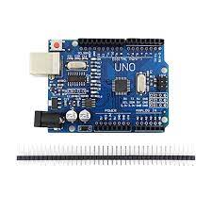

The Arduino Uno is a microcontroller board based on an 8-bit ATmega328P microcontroller. It includes other components to support the microcontroller such as crystal oscillator, serial communication, voltage regulator, etc. The Arduino Uno has 14 digital input / output pins (6 of which can be used as PWM output), 6 analog inputs, one USB connection, one power barrel jack, ICSP header and one There is a reset button. The 14 digital input/output pins can be used as input or output pins by using pinMode(), digitalRead() and digitalWrite() functions in Arduino programming. Each pin operate at 5V.

* **Buzzer:**

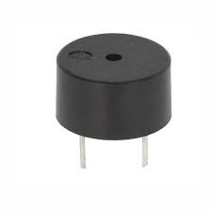 A buzzer is connected with the Arduino. A buzzer is a tinny speaker that connect directly to an Arduino. From Arduino we can make sound with a buzzer.

* **LED:**

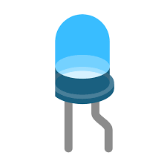LED (Light Emitting Diode) is an electronic device, which emits light when the current passes through its terminals. LED's are used in various applications. It is also used as an ON/OFF indicator in different electronic devices.

* **DC Motor:**

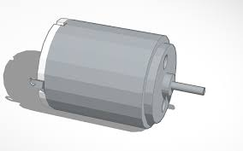A DC motor (Direct Current motor) is the most common type of motor. DC motors normally have just two leads, one positive and one negative. If you connect these two leads directly to a battery, the motor will rotate. If you switch the leads, the motor will rotate in the opposite direction.

* **Sensors :**

To build the Soil Moisture & Tank level Circuit we use the following sensors.

1. Soil Moisture Sensor
2. Temperature Sensor
3. Ultrasonic sensor

**1.Soil Moisture Sensor:**

A soil moisture sensor as the name indicates is used to determine the moisture present in the soil. The moisture of the soil depends upon various factors such as type of soil whether its sandy, clay, loam, sandy loam and salts present in soil such as iron, manganese, calcium, phosphorus, nitrogen, sulphur etc. it also depends upon temperature. Based on the reading of moisture sensor, irrigation is done.

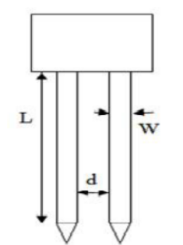 This Sensor measures the volumetric content of water inside the soil and gives us the moisture level as output. When the soil is having water shortage, the module output is at high level, else the output is at low level. This Sensor reminds the user to water their plants and also monitors the moisture content of soil. The Soil Moisture Sensor uses capacitance to measure the water content of soil (by measuring the dielectric permittivity of the soil, which is a function of the water content). It has been widely used in agriculture, land irrigation and botanical gardening.

**Working Principle:**

* Soil moisture Sensor has two conducting plates. As you can see it consists of two probes which are used to measure the volumetric content of water. The two probes allow the current to pass through the soil and then it gets the resistance value to measure the moisture value.
* From the figure, The length (L) of nickel probes is 9.5cm and width (W) of each probe is 0.7cm. The distance (d) between the two probes is 0.5cm the tips of sensor probes are designed in the shape of the triangle so that can be easily buried in the soil.
* First plate is connected to the +5 Volt supply through series resistance of 10K ohm and second plate is connected directly to the ground.
* It simply acts as a voltage divider bias network, and output is taken directly from the first terminal of the Sensor pin, which is shown in figure above.
* The output will change in the range of 0 – 5 Volt, in proportion with change in content of water in the soil.
* Ideally, when there is zero moisture in soil, the Sensor acts as open circuit i.e. infinite resistance. For this condition, we get 5 V at the output.
* So, when there is more water, the soil will conduct more electricity which means that there will be less resistance. Therefore, the moisture level will be higher. Dry soil conducts electricity poorly, so when there will be less water, then the soil will conduct less electricity which means that there will be more resistance. Therefore, the moisture level will be lower.
* This Sensor can be connected in two modes; Analog mode and digital mode. we will connect it in Analog mode.

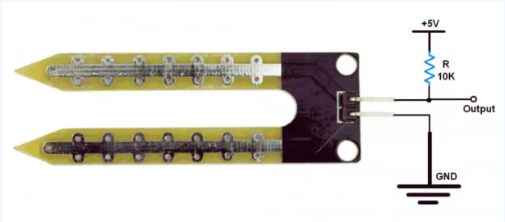

**Block Diagram:**

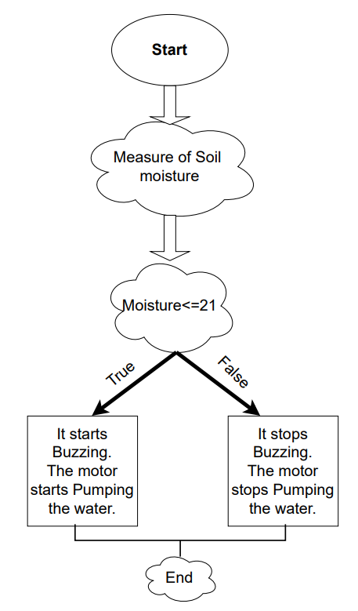

**Circuit Diagram:**

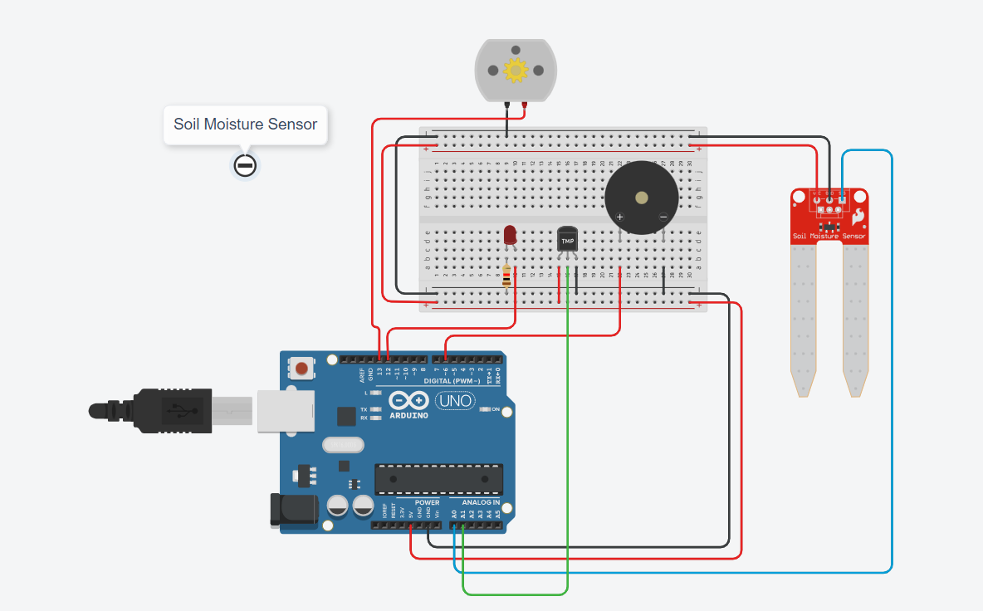

**SPECIFICATION**

* The required voltage for working is 5V
* The required current for working is <20mA
* Type of interface is analog.
* The required working temperature of this sensor is 10°C~30°C

**APPLICATIONS**

The applications of moisture sensor include the following:

* Agriculture
* Landscape irrigation
* Research
* Simple sensors for gardeners
* Archaeology
* Biofuel Studies
* Erosion Studies
* Drought Forecasting Model
* Dust Control ..etc

**LtSpice of Soil Moisture sensor:**

**Circuit diagram:**

**Soil Moisture sensor:**

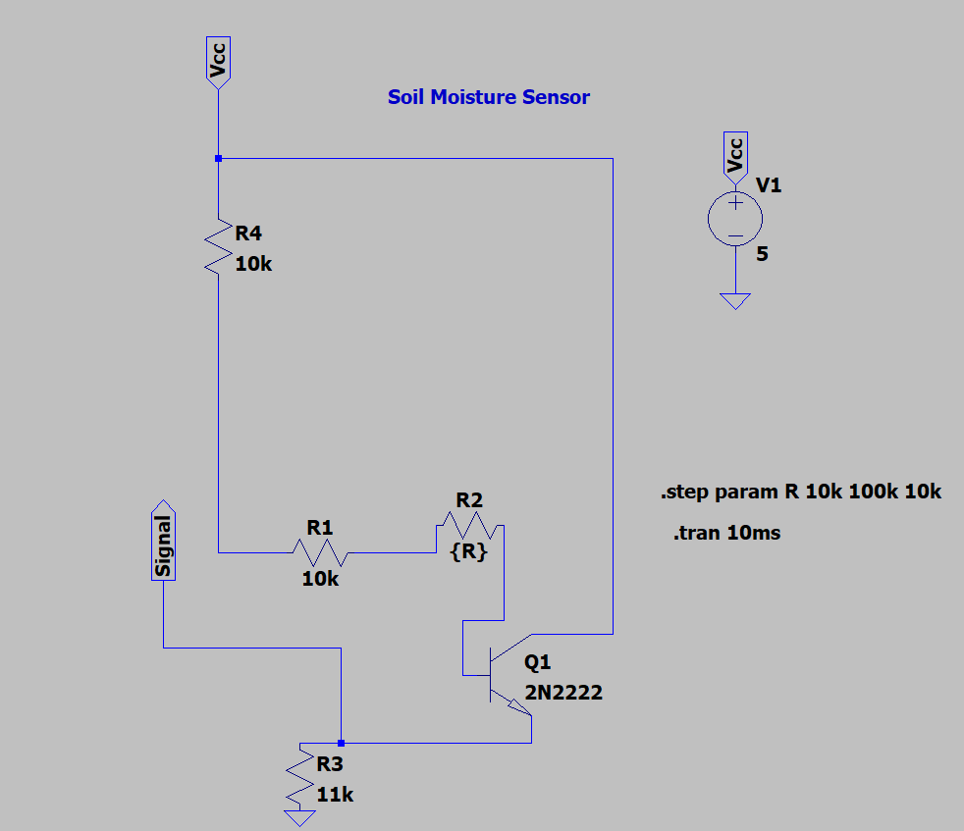

**Output:**

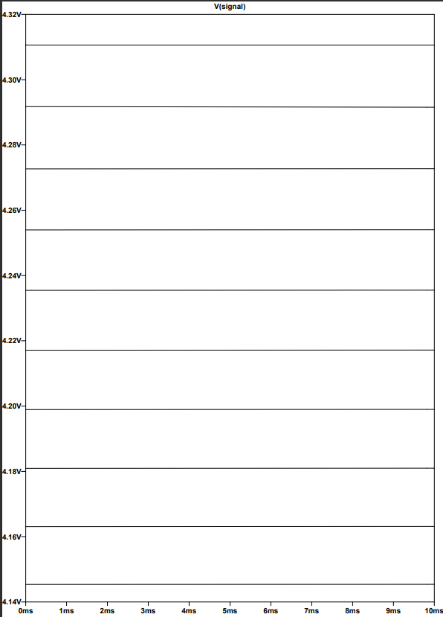

**Code:**

#include <LiquidCrystal.h>

int Mositure_data = A0;

float Mositure_percentage;

int Motor;

int LED = 12;

int siren = 6;

// Read -40c and 125c

int tempPin=A1;

double sensorValue;

double sensorValueC;

void setup()

{

pinMode(A0, INPUT);

Serial.begin(9600);

pinMode(12, OUTPUT);

pinMode(siren, OUTPUT);

pinMode(13, OUTPUT);

}

void loop()

{

Temperature_Indicator();

float Mositure_data = analogRead(A0);

Mositure_percentage=((Mositure_data/539.00)*100);

Serial.print("\n Mositure_data");

Serial.print( Mositure_percentage);

Serial.print("%");

Serial.println(Motor);

if (Mositure_data < 21) {

digitalWrite(12, HIGH);

digitalWrite(6, HIGH);

digitalWrite(13, HIGH);

tone(siren, 200,1000);

} else {

digitalWrite(12, LOW);

digitalWrite(6, LOW);

digitalWrite(13, LOW);

noTone(siren);

}

delay(10);

}

void Temperature_Indicator(){

sensorValue=analogRead(tempPin);

sensorValueC=(double)sensorValue/1024;

sensorValueC=sensorValueC*5;

sensorValueC=sensorValueC-0.5;

sensorValueC=sensorValueC*100;

Serial.println(sensorValueC);

Serial.println("C");

}

**2.Temperature Sensor:**

We have used the temperature sensor in soil moisture senor circuit itself.

The TMP36 temperature sensor is an easy way to measure temperature using an Arduino! The sensor can measure a fairly wide range of temperature (-50°C to 125°C), is fairly precise (0.1°C resolution), and is very low cost, making it a popular choice. All these features make this chip suitable for use in a variety of temperature measuring applications. These devices provide stable operation along with capacitive loads and drive 10,000 pF load without creating any oscillations.

**Properties:**

* Input voltage Range: 2.7V to 5.5V
* Current Draw: 50 µA
* Temperature Range: -40 °C to 125 °C
* Accuracy: ±2°C
* Output Voltage Range: 0.1V (-40°C) to 1.75V (125°C)

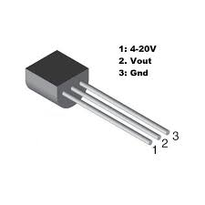**Applications:**

The TMP36 sensor gives the analogue output based on the temperature it is exposed to.

**Principle:**

The TMP36 sensor uses a semi-conductor technique to measure the temperature. It measures the temperature by using the fact that the potential difference between base and the emitter of a transistor changes with temperature at which the transistor is operating. Using the same principle, the following circuit is implemented in LTspice. An attempt is made to make the no of terminals of the implemented sensor equal to the original TMP36 sensor

**Circuit diagram:**

**TMP36**

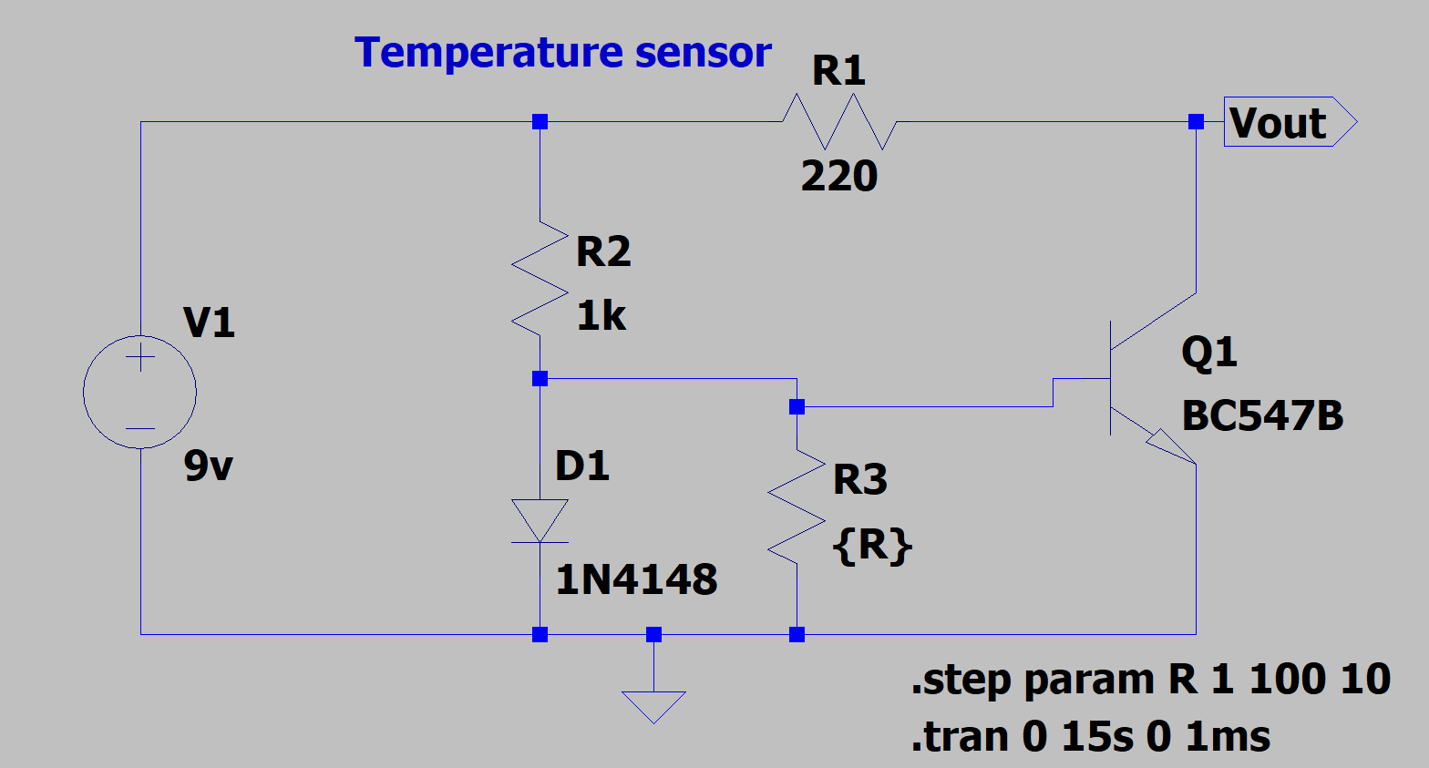

The collector current rises when heat is present or when the temperature rises to a point where it exceeds the threshold. Then, after giving Arduino Vout, it checks to see if the temperature is within the predetermined range. The variable resistor needs to be set before you can test the circuit. After rotating the Vout will be 0 if the potentiometer is fully turned in one direction. Vout will rise, going entirely in the opposite direction. Base-Emitter voltage (VBE) decreases by approximately -2.5 mV/°C, with a negative sign the voltage drop or reduction between B and E

If we short the transistor's base (B) and collector (C), the NPN transistor must behave like a diode. Then, emitter (E) serves as the negative terminal while B-C serves as the positive terminal. Additionally, if the voltage source is kept constant, the voltage across the transistor will depend on the ambient temperature. E will be the positive terminal and B-C will be the negative terminal for PNP transistors. Therefore, we may utilise the transistor as a temperature sensor by shorting the B and C.

**Output:**

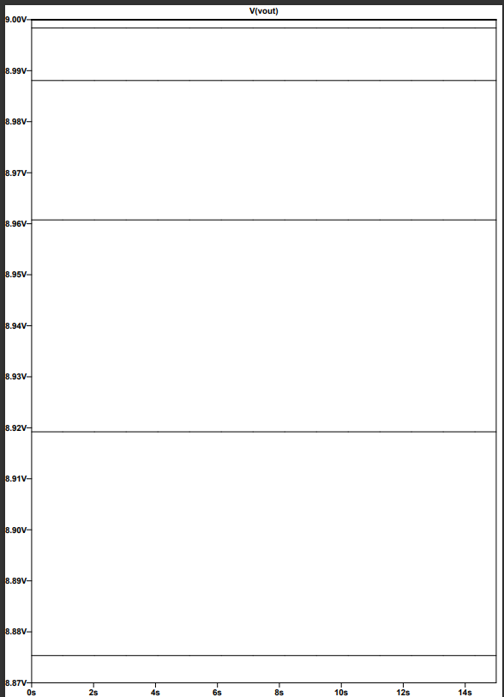

**3.Ultrasonic sensor:**

An Ultrasonic sensor is a device that can measure the distance to an object by using sound waves. It measures distance by sending out a sound wave at a specific frequency and listening for that sound wave to bounce back. By recording the elapsed time between the sound wave being generated and the sound wave bouncing back, it is possible to calculate the distance between the sonar sensor and the object.

**Distance Calculation:**

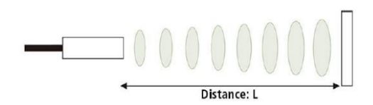

The distance can be calculated with the following formula:

Distance(L)=1/2*T*C

Where

L is the distance

T is the time between the emission(starting of the waves from the sensor) and reception(return of waves to the sensor).

C is the Sonic speed.

**Working:**

An Ultrasonic sensor is used in the transmitter circuit, which measures the distance of liquid level from the upper point of the Container. The distance is measured in centimetres and sent to receiver circuit using RF communication. The receiver circuit receives data from the transmitter and converts it by percentage and display on the LCD. Ultrasonic sensor has two openings, one is Trigger and the other is Echo. Trigger makes high frequency sound waves. These sound waves are passed through the tank from top to bottom. The sound waves hit the water and are reflected back in the form of Echo waves. The Echo opening receives the Echo waves. The water level sensor Arduino measures the time between Echo and Trigger. The working of the ultrasonic sensors is shown in the given diagram.

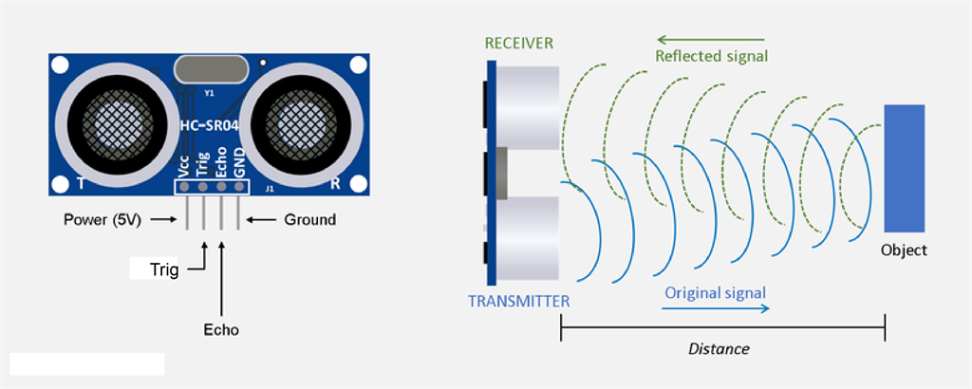

* VCC supplies power to the HC-SR04 ultrasonic sensor. You can connect it to the 5V output from your Arduino.
* Trig (Trigger) pin is used to trigger ultrasonic sound pulses. By setting this pin to HIGH for 10µs, the sensor initiates an ultrasonic burst.
* Echo pin goes high when the ultrasonic burst is transmitted and remains high until the sensor receives an echo, after which it goes low. By measuring the time the Echo pin stays high, the distance can be calculated.
* GND is the ground pin. Connect it to the ground of the Arduino.

**Block Diagram:**

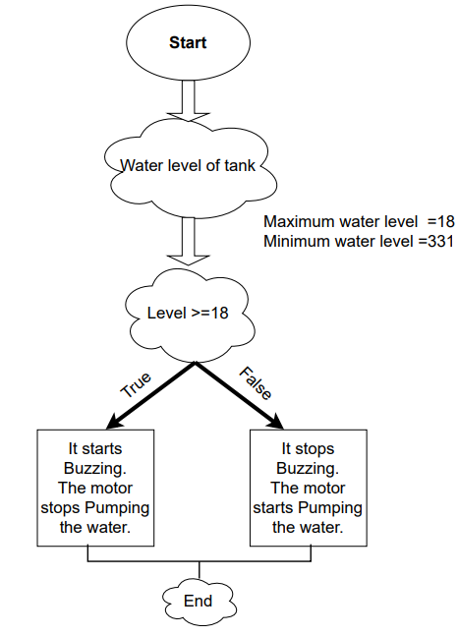

**Ltspice Schematic :**

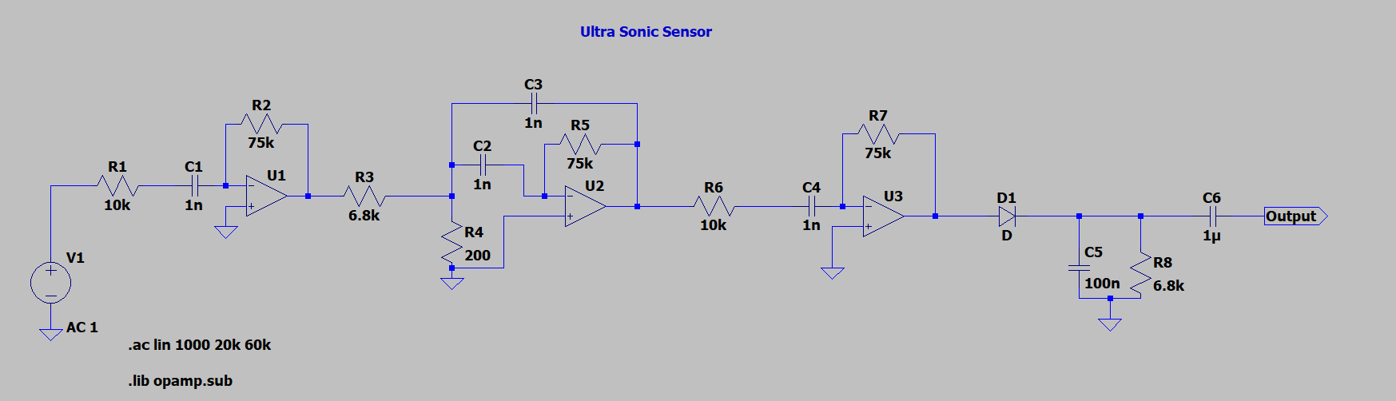

**Output:**

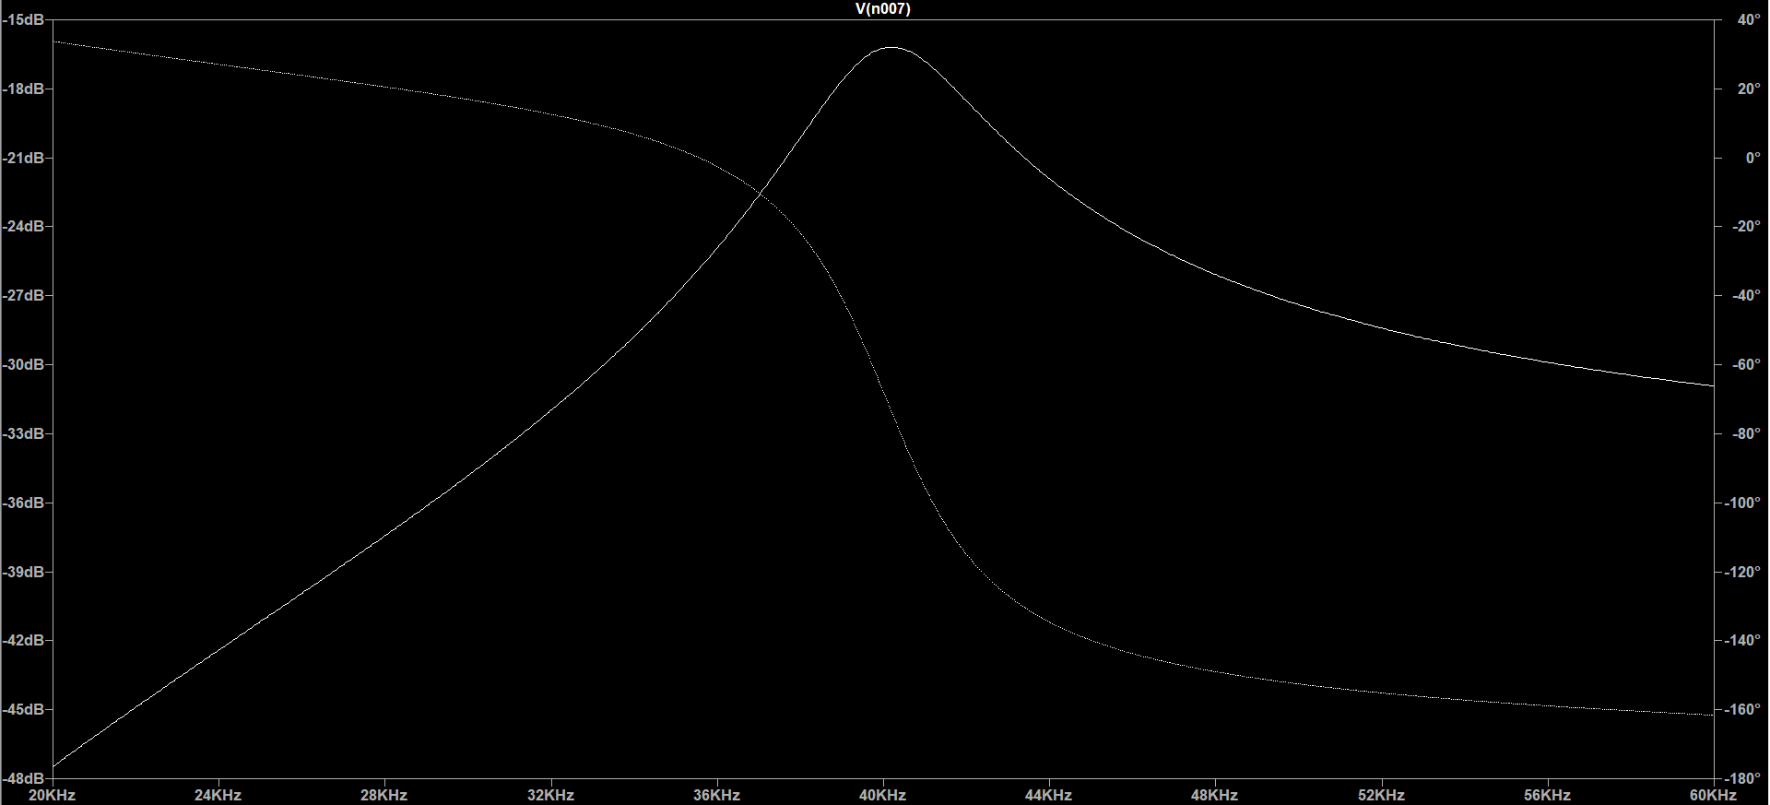

**Specifications:**

Operating Voltage DC 5V

Operating Current 15mA

Operating Frequency 40KHz

Max Range 4m

Min Range 2cm

Ranging Accuracy 3mm

Measuring Angle 15 degree

Trigger Input Signal 10µS TTL pulse

Dimension 45 x 20 x 15mm

**Limitations:**

* The distance between the sensor and the object/obstacle is greater than 13 feet.
* The object has its reflective surface at a shallow angle so that the sound is not reflected back to the sensor.
* The object is too small to reflect enough sound back to the sensor. Also, if your HC-SR04 sensor is mounted low on your device, you are likely to get sound reflecting off the floor.
* Some objects with soft, irregular surfaces (such as stuffed animals) absorb sound rather than reflect it, so the HC-SR04 sensor may find it difficult to detect such objects.

**Tinkercad Simulations:**

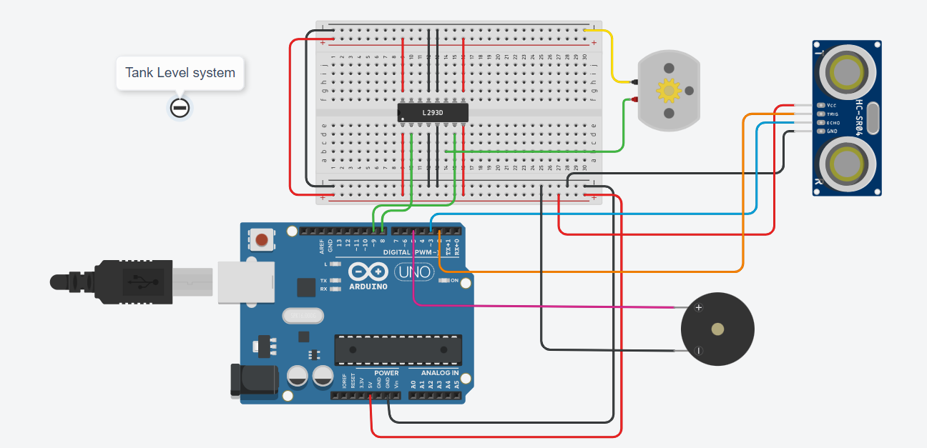

**Code:**

int LevelSensorVal = 0;

int echoPin = 0;

int triggerPin = 0;

long readUltrasonicDistance(int triggerPin, int echoPin)

{

pinMode(triggerPin, OUTPUT); // Clear the trigger

digitalWrite(triggerPin, LOW);

delayMicroseconds(2);

// Sets the trigger pin to HIGH state for 10 microseconds

digitalWrite(triggerPin, HIGH);

delayMicroseconds(10);

digitalWrite(triggerPin, LOW);

pinMode(echoPin, INPUT);

// Reads the echo pin, and returns the sound wave travel time in microseconds

return pulseIn(echoPin, HIGH);

}

void setup()

{

Serial.begin(9600);

pinMode(8, OUTPUT);

pinMode(9, OUTPUT);

pinMode(5, OUTPUT);

}

void loop()

{

echoPin = 3;

triggerPin = 2;

LevelSensorVal = 0.01723 * readUltrasonicDistance(2, 3);

Serial.println("Level Control System");

Serial.println(LevelSensorVal);

if (LevelSensorVal <= 40) {

Serial.println("Tank is FULL");

//digitalWrite(8, HIGH);

digitalWrite(9, LOW);

//tone(5, 19, 1000); // play tone 3 (D#0 = 19 Hz)

digitalWrite(5,HIGH);

}

else if(LevelSensorVal>40 && LevelSensorVal<300)

{

Serial.println("Tank is filling");

digitalWrite(9, HIGH);

digitalWrite(5, LOW);

}

else if (LevelSensorVal > 300) {

Serial.println("Tank is EMPTY");

// digitalWrite(8, LOW);

digitalWrite(9, HIGH);

}

// else (LevelSensorVal < 300); {

// digitalWrite(8, LOW);

//digitalWrite(9, LOW);

//}

delay(10); // Delay a little bit to improve simulation performance

}

**Conclusion:**

From this mini project we can conclude that saving of water can be done in all the various situations like smart irrigation and the water level system using the ultrasonic sensor which calculate the distance. Smart irrigation is very useful and it is giving the best production of the crop. This is a low-cost, low-power, lightweight, portable, safe, user-friendly, efficient, multi-featured and simple system device for saving the water. The use of smart irrigation system has significantly reduced the wastage of water for agriculture and has even helped in proper watering of plants in each season this has even increased the agricultural production significantly compared to the previous years. From this we can have added the temperature sensor to calculate the temperature of the soil etc.

We have implemented the automatic machine for the tank water full system. In this system we have done the automatic stop and start the motor when the tank is full or fulling the tank.

Like this we can save the water on each step of your life for your future generations.

**References:**

* arduino.cc/reference/en/
* <https://bc-robotics.com/tutorials/using-a-tmp36-temperature-sensor-with-arduino/>

**Tinkercad link:**

* <https://www.tinkercad.com/things/iA5go0WWZd5-soil-moisture-sensor/editel>
* <https://www.tinkercad.com/things/8XSp5YyhDTu-tank-full-system/editel>

**Software used:**

